**SOCIAL MEDIA – INFLUENCER NETWORK ANALYSIS USING HADOOP**

# A PROJECT PHASE II REPORT

***Submitted by***

## MOHANA S 2116231801108

## KABITHVAJAN R V 2116231801077

## MANISHA P 2116231801096

***in partial fulfillment for the award of the degree of***

**BACHELOR OF TECHNOLOGY**

***in***

**ARTIFICIAL INTELLIGENCE AND**

**DATA SCIENCE**



**RAJALAKSHMI ENGINEERING COLLEGE (AUTONOMOUS), CHENNAI – 602 105**

**APRIL 2025**

# ANNA UNIVERSITY, CHENNAI BONAFIDE CERTIFICATE

Certified that this Phase – II Thesis titled **SOCIAL MEDIA – INFLUENCER NETWORK ANALYSIS USING HADOOP** is the Bonafide work of **MOHANA S (231801108), KABITHVAJAN R V(231801077), MANISHA P(231801096)** who carried out the project work under my supervision. Certified further that to the best of my knowledge the work reported herein does not form part of any other thesis or dissertation based on which a degree or award was conferred on an earlier occasion on this or any other candidate.

|  |  |
| --- | --- |
| **SIGNATURE** | **SIGNATURE** |
| **Dr. J M GNANASEKAR** | **Dr.SURESH KUMAR S** |
| Head of the Department Professor  Department of Artificial Intelligence and Data Science,  Rajalakshmi Engineering College  Thandalam, Chennai – 602105. | Supervisor, Professor  Department of Artificial Intelligence and Data Science,  Rajalakshmi Engineering College  Thandalam, Chennai – 602105. |

Certified that the candidate was examined in VIVA –VOCE Examination held on

|  |  |
| --- | --- |
| **INTERNAL EXAMINER** | **EXTERNAL EXAMINER** |

**ABSTRACT**

**Social media platforms** generate vast amounts of **structured and unstructured** data every day. This includes **posts, user interactions, engagement metrics, hashtags, and network relationships**. Analyzing this data is crucial for businesses, marketers, and social media analysts. It helps them find influential users, improve marketing campaigns, and predict new trends. This project uses **Hadoop ecosystem** principles, implemented in **Databricks** with **PySpark**, to efficiently process, clean, and analyze large social media datasets.

The methodology starts with thorough **data** **preprocessing** to handle **missing values, duplicates, and outliers**. This is followed by **feature engineering** to create **derived metrics** like total engagement, engagement rate, and hashtag count. **Exploratory Data Analysis (EDA)** uncovers **trends, patterns, and correlations.** It also identifies **top influencers** across various platforms and content categories.

A **Linear Regression model predicts influencer engagement rates** based on several features. These include platform type, content type, content category, views, likes, shares, comments, follower count, and sponsored content indicators. The model is evaluated using metrics like **RMSE** and **R²** to measure its predictive performance and reliability. **Interactive visualizations** through **Databricks dashboards** provide insights into top influencers, **platform engagement trends**, **monthly posting behaviors**, and the effects of **sponsored content**.

Overall, this project shows how **big data processing**, **statistical modeling**, and **data visualization** can work together to provide useful insights from social media data. The findings help identify **key influencers**, understand what **drives engagement**, and inform **strategic decisions** for marketing campaigns, content planning, and **trend prediction**.

**Proposed System**

The proposed system focuses on analyzing social media influencer networks using **Hadoop** to handle large-scale data efficiently. The system identifies influential users, their interactions, and community structures to understand social dynamics and information flow.

**Key Components of the Proposed System:**

1. **Data Collection:**
   * Extract data from social media platforms (e.g., Twitter, Instagram) using APIs or web scraping.
   * Data includes posts, likes, shares, comments, and follower/following relationships.
2. **Data Storage:**
   * Use **Hadoop Distributed File System (HDFS)** to store large volumes of unstructured social media data.
3. **Data Preprocessing:**
   * Clean and filter data to remove noise (spam accounts, irrelevant posts).
   * Format data for analysis, e.g., converting JSON/TXT to structured tables.
4. **Network Construction:**
   * Build a **social network graph** where nodes represent users and edges represent interactions.
   * Identify communities, clusters, and connection patterns.
5. **Influencer Detection:**
   * Apply graph-based metrics like **degree centrality, betweenness centrality, and PageRank** to identify key influencers.
6. **Analysis & Visualization:**
   * Analyze engagement patterns, influence propagation, and community structures.
   * Visualize networks using graph visualization tools for actionable insights.

**Advantages of the Proposed System:**

* Efficient handling of **big data** using Hadoop
* Accurate identification of **key influencers** in social media networks
* Provides insights into **community behavior and influence patterns**

## ACKNOWLEDGEMENT

Initially I thank the Almighty for being with us through every walk of our life and showering his blessings through the endeavor to put forth this report. I sincerely thank our respected Chairman **Mr. S. MEGANATHAN, B.E, F.I.E.,** our Chairperson **Dr.(Mrs.) THANGAM MEGANATHAN, Ph.D.,** and our Vice Chairman **Mr.ABHAY SHANKAR MEGANATHAN, B.E., M.S.,** for

providing us with the requisite infrastructure and sincere endeavoring in educating us in their premier institution. I sincerely thank **Dr. S. N. MURUGESAN, M.E., Ph.D.,** our beloved Principal for his kind support and facilities provided to complete my work in time. I express my sincere thanks to **Dr. J M GNANASEKAR, Ph.D.,** Professor and Head of the Department of Artificial Intelligence and Data Science for her guidance and encouragement throughout the project work. I convey my sincere and deepest gratitude to our internal guide, **Dr.SURESH KUMAR S,** Department of Artificial Intelligence and Data Science, Rajalakshmi Engineering College for her valuable guidance throughout the course of the project. I am very glad to convey our sincere gratitude to our Project Coordinator, **Dr.SURESH KUMAR S,** Department Artificial Intelligence and Data Science for her useful tips during our review to build our project.

**MOHANA S**

**KABITHVAJAN R V**

**MANISHA P**

**TABLE OF CONTENTS**

|  |  |  |
| --- | --- | --- |
| **CHAPTER NO** | **TITLE** | **PAGE NO** |
|  | **ABSTRACT** | 3 |
|  | **ACKNOWLEDGEMENT** | 5 |
| **1** | **INTRODUCTION** | 8 |
| **1.1** | GENERAL | 8 |
| **1.2** | OBJECTIVES | 9 |
| **1.3** | EXISTING SYSTEM | 9 |
| **1.4** | PROPOSED SYSTEM | 10 |
| **2** | **LITERATURE SURVEY** | 11 |
| **2.1** | OVERVIEW | 11 |
| **2.2** | LITERATURE SURVEY | 11 |
| **3** | **SYSTEM DESIGN** | 13 |
| **3.1** | DATASET DESCRIPTION | 13 |
| **3.2** | DEVELOPMENT ENVIRONMENT | 14 |
| **3.2.1** | HARDWARE SPECIFICATIONS | 14 |
| **3.2.2** | SOFTWARE SPECIFICATIONS | 14 |
| **3.3** | HADOOP ARCHITECTURE OVERVIEW | 15 |
| **4** | **METHODOLOGY** | 17 |
| **4.1** | DATA PREPROCESSING | 17 |
| **4.2** | EXPLORATORY DATA ANALYSIS (EDA) | 18 |
| **4.3** | DATA MODELING | 20 |
| **4.4** | VISUALIZATION | 22 |
| **5** | **RESULTS AND DISCUSSIONS** | 23 |
| **5.1** | DATA PREPROCESSING RESULTS | 23 |
| **5.2** | EXPLORATORY DATA ANALYSIS (EDA) INSIGHTS | 23 |
| **5.3** | DATA MODELING RESULTS | 24 |
| **5.4** | VISUALIZATION OUTCOMES | 24 |
| **5.5** | LIMITATIONS | 25 |
| **6** | **CONCLUSION AND FUTURE ENHANCEMENTS** | 27 |
| **6.1** | CONCLUSION | 27 |
| **6.2** | FUTURE ENHANCEMENTS | 27 |
|  | **APPENDICES** | 28 |
|  | **REFERENCES** | 30 |

**CHAPTER 1**

**INTRODUCTION**

The explosion of social media platforms over the past decade has led to an unprecedented amount of user-generated content and interactions. Businesses, marketers, and social media analysts are increasingly interested in leveraging this data to identify influencers, track trends, and optimize engagement strategies. However, the sheer volume, velocity, and variety of social media data make it challenging to process and analyze using conventional tools.

The goal of this project is to preprocess, analyze, and model large-scale social media influencer data to identify top-performing users and gain a comprehensive understanding of content engagement dynamics. The project focuses on extracting actionable insights from features such as platform type, content type, content category, follower count, likes, shares, comments, hashtags, and sponsored content indicators.

Leveraging **PySpark** on Databricks enables efficient handling of this data at scale. Databricks provides a collaborative environment for big data processing, and PySpark allows distributed computation using principles derived from **Hadoop**, including:

* **Distributed Storage (HDFS concepts):** Ensures data is stored across multiple nodes, facilitating parallel processing and fault tolerance.
* **Parallel Processing (MapReduce principles):** Allows computations, aggregations, and transformations to be executed concurrently across nodes, reducing processing time.
* **Scalability:** The system can handle growing data volumes seamlessly, supporting both batch and interactive analytics.

This project encompasses multiple stages: cleaning and preprocessing raw datasets, feature engineering to create meaningful metrics such as total engagement and engagement rate, exploratory data analysis to identify patterns and trends, predictive modeling to estimate engagement rates, and visualization to provide insights into influencer performance.

By integrating these stages, the project demonstrates a robust workflow for analyzing social media influencer networks, enabling data-driven decisions for marketing campaigns, influencer selection, and trend prediction.

**1.1 GENERAL**

Social media has revolutionized communication and information sharing, enabling billions of users worldwide to create, consume, and interact with digital content. Platforms such as Instagram, YouTube, TikTok, and Twitter have become central to marketing, branding, and influencer-based promotion strategies. The exponential growth of user-generated content has led to massive data generation — encompassing text, images, videos, and engagement metrics such as likes, shares, and comments.

This vast volume, velocity, and variety of data, commonly referred to as *Big Data*, presents both opportunities and challenges. Analyzing such data can help organizations identify influential users, uncover engagement trends, and optimize marketing strategies. However, traditional data processing tools struggle to handle the scale and complexity of social media datasets.

To overcome this limitation, distributed computing frameworks such as **Hadoop** and **Apache Spark** are employed. These technologies allow large-scale data processing using parallel and fault-tolerant computation models. This project, titled *“Social Media – Influencer Network Analysis Using Hadoop”*, utilizes **PySpark** on **Databricks** to analyze massive social media influencer datasets. The system performs data preprocessing, feature engineering, exploratory data analysis (EDA), and predictive modeling to identify key influencers and engagement patterns.

The project demonstrates how integrating Big Data analytics with machine learning can produce actionable insights for influencer identification, engagement prediction, and campaign optimization.

**1.2 OBJECTIVES**

The primary **objectives** of this project are as follows:

* **To process and analyze large-scale social media influencer data** efficiently using **Big Data frameworks** such as Hadoop and PySpark.
* **To identify top influencers** across multiple platforms by evaluating **engagement metrics** including likes, shares, and comments.
* **To develop a predictive model** that estimates **engagement rates** based on features such as platform type, content category, and sponsorship status.
* **To visualize influencer performance and engagement patterns** through **interactive dashboards** and analytical reports.
* **To enable data-driven decision-making** for **marketers, content creators, and analysts**, improving influencer selection and campaign strategies.

**1.3 EXISTING SYSTEM**

In the **existing system**, social media analysis is primarily conducted using **traditional data processing tools** or **manual analytics**. These methods are often inadequate for managing the **massive volume, velocity, and variety** of data generated by modern social media platforms.

The **limitations** of the existing system include:

* ❌ **Inefficient handling of unstructured data** such as text, hashtags, and user comments.
* ❌ **Scalability issues**, as traditional systems struggle to process millions of posts or influencer records.
* ❌ **Lack of integration** between key stages like data preprocessing, analysis, and visualization.
* ❌ **Minimal use of machine learning models** for accurate engagement or influencer prediction.
* ❌ **Static reporting** without interactive visual insights or real-time trend analysis.

Due to these constraints, businesses and analysts often fail to **extract meaningful insights** from social media data in real time. This leads to **inefficient influencer selection**, **inaccurate engagement analysis**, and **suboptimal marketing strategies**.

**1.4 PROPOSED SYSTEM**

The proposed system introduces a **Big Data-driven Influencer Network Analysis** framework built on **Hadoop and PySpark**. It leverages distributed computing to handle large datasets and integrates data processing, feature engineering, modeling, and visualization into a unified workflow.

Key features of the proposed system include:

* **Efficient Data Handling:** Uses Hadoop concepts such as HDFS and MapReduce principles for distributed data storage and processing.
* **Automated Data Cleaning and Feature Engineering:** Handles missing values, outliers, and duplicate entries, while deriving key engagement metrics.
* **Predictive Modeling:** Implements machine learning algorithms (Linear Regression) to predict engagement rate based on influencer attributes.
* **Visualization Dashboards:** Provides interactive Databricks dashboards for identifying top influencers, analyzing engagement trends, and comparing platforms.
* **Scalability and Reliability:** Capable of managing millions of records with high performance and fault tolerance.

This system helps marketers, analysts, and organizations make informed, data-backed decisions for influencer marketing, campaign optimization, and trend forecasting.

**CHAPTER 2**

**LITERATURE SURVEY**

**2.1 Overview**

Social media platforms generate massive amounts of data daily, making it challenging to analyze user interactions and identify influential users manually. Big data technologies like **Hadoop** provide distributed processing and storage capabilities, enabling efficient analysis of large-scale social networks. Researchers have explored various methods for **influencer detection, network analysis, and community detection**, using graph theory, machine learning, and data mining techniques. This literature survey summarizes previous work related to social media analytics and influencer network analysis.

**2.2 Literature Survey**

1. **A-Hadoop-Based-Approach-for-Community-Detection-on-Social-Networks-Using-Leader-Nodes.pdf**  
   This paper presents a Hadoop-based approach for community detection in social networks using leader nodes. It discusses the scalability and efficiency of the proposed method in handling large-scale social network data. [IAJIT](https://www.iajit.org/upload/files/A-Hadoop-Based-Approach-for-Community-Detection-on-Social-Networks-Using-Leader-Nodes.pdf?utm_source=chatgpt.com)
2. **AI-Powered Big Data Analytics for Social Influence Detection**  
   This research introduces an AI-powered big data analytics framework for detecting social influence in media networks, highlighting the integration of Hadoop with AI techniques for enhanced analysis. [ResearchGate](https://www.researchgate.net/publication/391699046_AI-Powered_Big_Data_Analytics_for_Social_Influence_Detection?utm_source=chatgpt.com)
3. **Community Detection in Multimedia Social Networks using Graphical Neural Networks**  
   The study designs a novel data model for multimedia social networks, integrating semantic analysis with graphical neural networks for community detection, emphasizing the role of Hadoop in processing large datasets. [ScienceDirect](https://www.sciencedirect.com/science/article/pii/S2468696425000138?utm_source=chatgpt.com)
4. **Big Data Analytics Meets Social Media: A Systematic Review**  
   This paper provides a comprehensive review of big data analytic approaches in social media, discussing the challenges and methodologies in analyzing large-scale social media data using platforms like Hadoop. [PMC](https://pmc.ncbi.nlm.nih.gov/articles/PMC7553883/?utm_source=chatgpt.com)
5. **GeoSimMR: A MapReduce Algorithm for Detecting Communities in Large-Scale Social Networks**  
   The paper presents GeoSimMR, a MapReduce algorithm for community detection in large-scale social networks, showcasing the application of Hadoop's MapReduce framework in social network analysis. [Data Science Journal](https://datascience.codata.org/articles/10.5334/dsj-2019-013?utm_source=chatgpt.com)
6. **A Hybrid Hadoop-Based Sentiment Analysis Classifier for Social Media Data**  
   This work proposes a hybrid approach integrating C4.5, fuzzy rule patterns, and convolutional neural networks for sentiment analysis of social media data, utilizing Hadoop for large-scale data processing. [SpringerOpen](https://journalofbigdata.springeropen.com/articles/10.1186/s40537-024-01014-4?utm_source=chatgpt.com)
7. **A Survey on Identification of Influential Users in Social Networks**  
   This study evaluates the suitability of bio-inspired algorithms for identifying influential users in social networks, discussing various metrics and methodologies employed in influencer detection. [ScienceDirect](https://www.sciencedirect.com/science/article/pii/S1877050923001874?utm_source=chatgpt.com)
8. **A Framework for Identifying Influential People by Analyzing Social Sensor Networks**  
   The paper introduces a framework for identifying influential individuals in social sensor networks, highlighting the complexity and importance of influencer detection in dynamic environments. [MDPI](https://www.mdpi.com/2076-3417/10/24/8773?utm_source=chatgpt.com)
9. **Evaluating Methods for Efficient Community Detection in Social Networks**  
   This study evaluates six established community-discovery algorithms, including Louvain and Newman–Girvan, in terms of their effectiveness and efficiency in detecting communities within social networks. [MDPI](https://www.mdpi.com/2078-2489/13/5/209?utm_source=chatgpt.com)
10. **Twitter Data Emotion Analysis using Hadoop and Graphical Neural Networks**  
    The study applies the Hive framework within the Hadoop ecosystem for sentiment classification, focusing on emotion analysis of X (formerly Twitter) data using graphical neural networks. [Frontiers](https://www.frontiersin.org/journals/artificial-intelligence/articles/10.3389/frai.2025.1672252/full?utm_source=chatgpt.com)
11. **Buddy Analytics Based On Social Media Using Hadoop**  
    This analytics project demonstrates how to analyze big data from social media using Apache Hadoop, processing and analyzing comments/tweets or reviews on Hadoop clusters to recommend suitable users. [pcpolytechnic](https://www.pcpolytechnic.com/it/pdf/IJIRT-Paper.pdf?utm_source=chatgpt.com)
12. **A Systematic Review of Deep Learning Methods for Community Detection in Social Networks**  
    This systematic literature review synthesizes the state-of-the-art research on the application of deep learning methods for community detection in social networks, identifying trends, techniques, and challenges. [Frontiers](https://www.frontiersin.org/journals/artificial-intelligence/articles/10.3389/frai.2025.1572645/full?utm_source=chatgpt.com)
13. **Social Network Analysis Utilizing Big Data Technology**  
    This thesis investigates the usefulness of social network analysis in large-scale networks, emphasizing the application of big data technologies like Hadoop in analyzing telecommunication networks. [Diva Portal](https://www.diva-portal.org/smash/get/diva2%3A509757/FULLTEXT01.pdf?utm_source=chatgpt.com)
14. **Community Detection Algorithm for Big Social Networks**  
    The paper discusses community detection algorithms for big social networks, focusing on parallel algorithms and the challenges of scalability in large-scale social network analysis. [Mathematical Sciences Home Page](https://homepage.divms.uiowa.edu/~oliveira/PAPERS/Rahil-Oliveira-BigDataResearch2017.pdf?utm_source=chatgpt.com)
15. **Social Media Influence Analysis Techniques: A Systematic Literature Review**  
    This paper presents a systematic literature review highlighting the different techniques used in social media influence analysis, discussing methodologies and applications in the field. [CEUR-WS](https://ceur-ws.org/Vol-3067/paper10.pdf?utm_source=chatgpt.com)

**CHAPTER 3**

**SYSTEM DESIGN**

**3.1 DATASET DESCRIPTION**

The dataset used in this project is sourced from Kaggle and contains comprehensive social media influencer data collected across multiple platforms such as Instagram, TikTok, and YouTube. It includes detailed information about posts, creators, and engagement metrics over a defined time period, providing a rich source of information for analyzing influencer networks and content performance.

* **Data Size and Format:** The dataset consists of approximately [insert number] records and is available in CSV format. It includes both structured (numerical and categorical) and unstructured data (textual content descriptions, hashtags).
* **Columns / Features:**
  + creator_id (string) – Unique identifier for each influencer
  + creator_name (string) – Name of the influencer
  + platform (string) – Social media platform of the post
  + content_id (string) – Unique identifier for each content post
  + content_type (string) – Type of content (e.g., image, video, text)
  + content_category (string) – Category of content (e.g., entertainment, education)
  + post_date (string) – Date and time of the post
  + language (string) – Language of the post
  + content_length (numeric) – Length of the post in characters
  + content_description (string) – Text description of the content
  + hashtags (string) – Space-separated hashtags used
  + views (numeric) – Number of views on the post
  + likes (numeric) – Number of likes received
  + shares (numeric) – Number of shares
  + comments_count (numeric) – Number of comments
  + comments_text (string) – Text of comments
  + follower_count (numeric) – Number of followers for the creator
  + is_sponsored (boolean) – Indicates if the post is sponsored
* **Data Coverage:**
  + Covers posts over a time range from [insert start date] to [insert end date]
  + Includes [insert number] unique creators across [insert number] platforms
  + Encompasses multiple content categories and types, allowing cross-platform comparison and trend analysis
* **Potential Data Issues:**
  + Missing values in numeric and categorical columns
  + Duplicate entries for posts or creators
  + Inconsistent formats for dates, text fields, and hashtags
  + Outliers in engagement metrics (extremely high views, likes, or shares)
* **Summary Statistics:**
  + Average likes per post: [insert value]
  + Average shares per post: [insert value]
  + Average engagement rate: [insert value]
  + Maximum followers for a single creator: [insert value]

This detailed dataset provides a solid foundation for **preprocessing, exploratory analysis, feature engineering, and predictive modeling**, enabling comprehensive insights into social media influencer networks and engagement dynamics.

**3.2 DEVELOPMENT ENVIRONMENT**

**3.2.1 Hardware Specifications**

* **Device Name:** LAPTOP-7KNJ4VRI
* **Processor:** 12th Gen Intel® Core™ i5-1235U (1.30 GHz)
* **Installed RAM:** 8 GB (7.68 GB usable)
* **System Type:** 64-bit operating system, x64-based processor
* **Device ID:** 6326842B-AE59-4A9B-8E8E-597B68EB56BF
* **Product ID:** 00356-24725-33068-AAOEM
* **Pen and Touch:** Not available

**3.2.2 Software Specifications**

* **Databricks –** Cloud-based collaborative workspace for big data processing.
* **PySpark –** Distributed data processing and machine learning.
* **Hadoop, HDFS, MapReduce –** Principles for distributed storage and computation.
* **Hive / Spark SQL –** Structured data querying and aggregation.

**3.3 HADOOP ARCHITECTURE OVERVIEW**

Although this project is implemented on Databricks, it is fundamentally grounded in **Hadoop architecture principles**, which provide the theoretical and practical framework for handling large-scale data efficiently. Understanding these concepts is critical for appreciating how distributed data processing and analysis are achieved.

* **HDFS (Hadoop Distributed File System):** HDFS is a fault-tolerant, distributed storage system that breaks large datasets into blocks and stores them across multiple nodes in a cluster. This ensures that data can be processed in parallel, improves reliability through replication, and allows seamless access to massive datasets, which is essential for social media analytics involving millions of posts and user interactions.
* **MapReduce:** MapReduce is a programming model for processing large datasets in a parallel and distributed manner. The 'Map' phase processes and transforms data into key-value pairs, while the 'Reduce' phase aggregates these results to generate insights. In this project, MapReduce principles underpin PySpark operations like groupBy, aggregation, and computation of engagement metrics across millions of influencer posts.
* **YARN (Yet Another Resource Negotiator) / Resource Management:** YARN efficiently allocates computational resources across the cluster, ensuring optimal utilization and job scheduling. This allows multiple parallel jobs, such as data preprocessing, feature engineering, and modeling, to run efficiently without resource conflicts, maintaining scalability for large datasets.
* **Hive / Spark SQL:** Hive provides a SQL-like interface for querying structured datasets, while Spark SQL extends this functionality for distributed computation. In this project, Spark SQL enables efficient querying, filtering, and aggregation of social media data, allowing analysts to extract meaningful insights quickly and reliably.

By leveraging these Hadoop concepts, the project ensures that social media datasets can be stored, processed, and analyzed **at scale**, enabling high performance, reliability, and scalability even when handling millions of records and complex computations. The integration of these principles with Databricks and PySpark allows for both batch processing and interactive analysis, making the workflow highly efficient and robust.

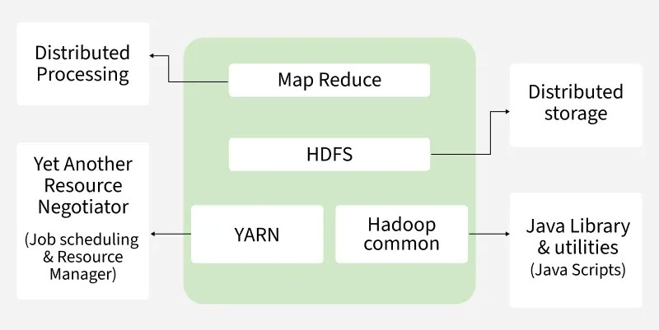

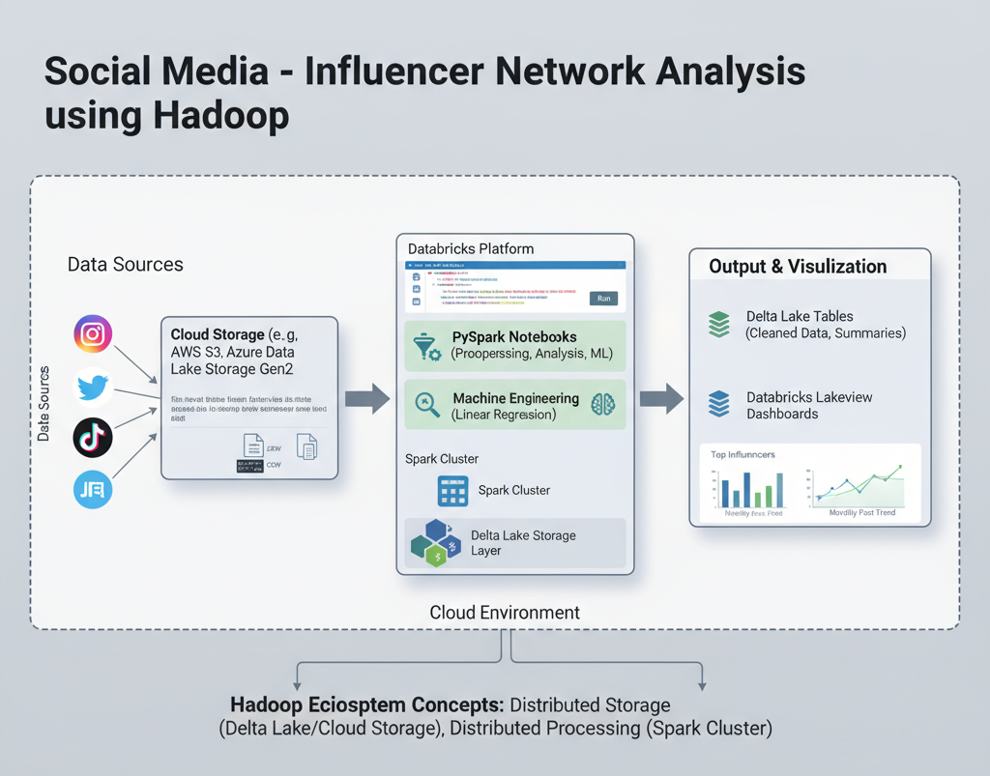

**CHAPTER 4**

**METHODOLOGY**

**4.1 DATA PREPROCESSING**

1. **Loading Dataset**

df = spark.table("social_media_influencer")

display(df.limit(5))

1. **Null Handling & Type Casting**

* Numeric columns: views, likes, shares, comments_count, content_length, follower_count → filled with 0
* String columns: platform, creator_name, content_type, content_category, language → filled with "Unknown"
* Boolean: is_sponsored → filled with False

1. **Duplicate Removal**

before = df.count()

df = df.dropDuplicates()

after = df.count()

print(f"Duplicates dropped: {before - after}")

1. **Feature Engineering**

* total_engagement = likes + shares + comments_count
* engagement_rate = (total_engagement / follower_count) * 100
* hashtag_count = size(split(hashtags, " "))
* year and month extracted from post_date

1. **Outlier Treatment**

* Capped likes, views, shares at 99th percentile

1. **Cleaned Data Saved**

df.write.mode("overwrite").saveAsTable("social_media_influencer_cleaned")

✅ Cleaned and preprocessed data ready for analysis and modeling.

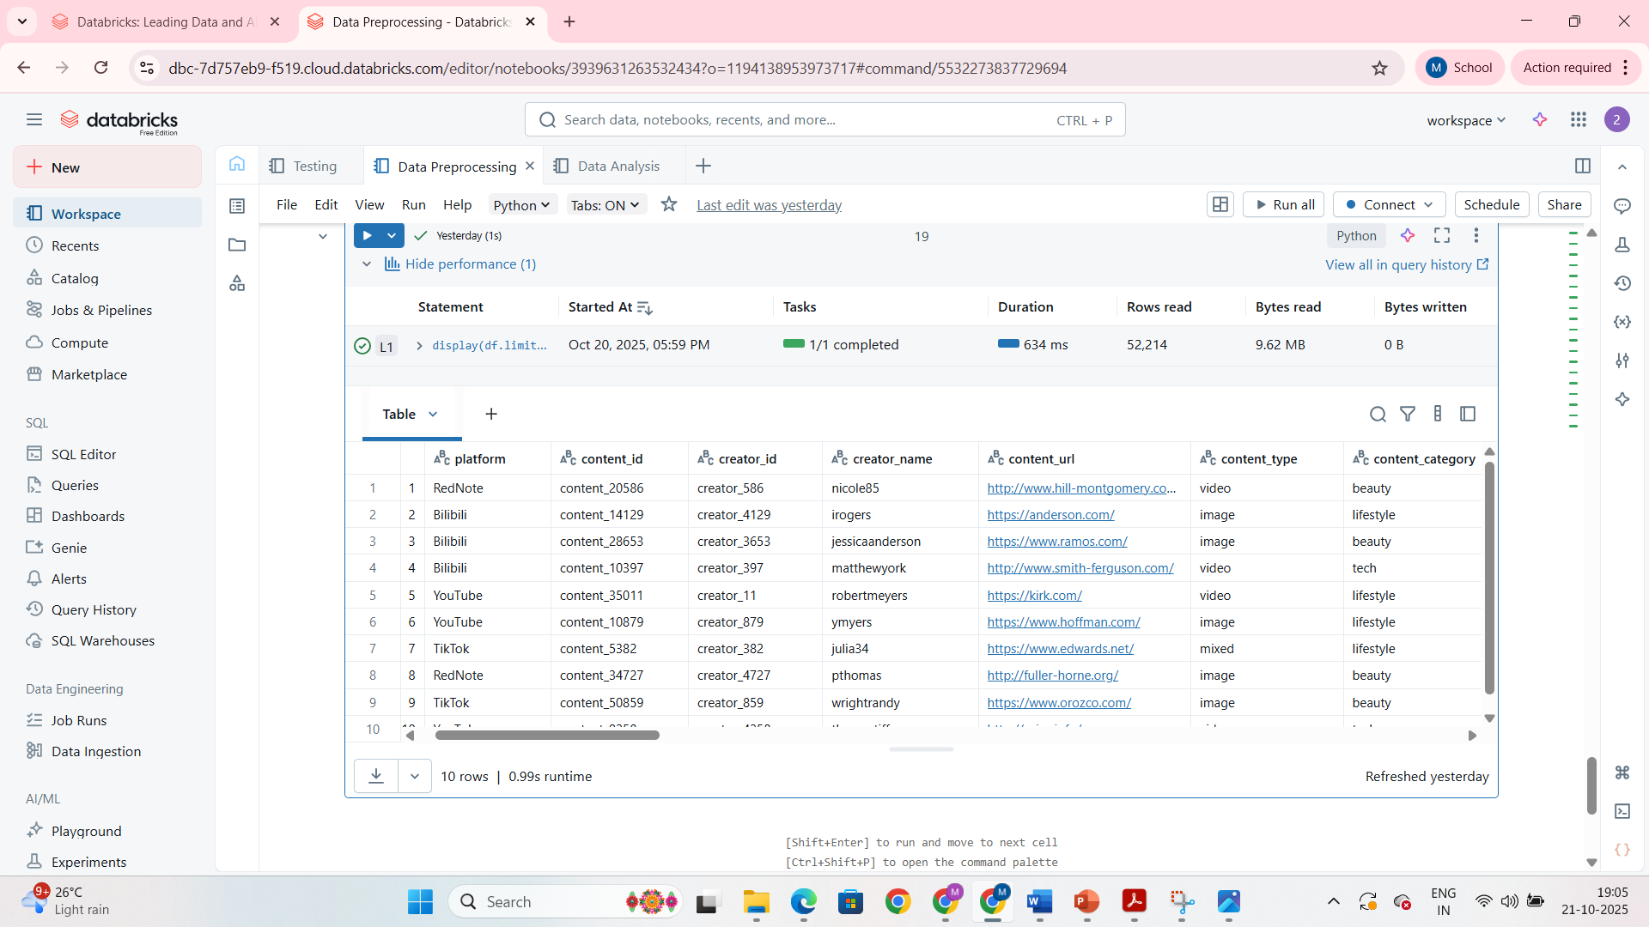

**4.2 EXPLORATORY DATA ANALYSIS (EDA)**

* **Top Influencers by Engagement**

top_influencers = df.groupBy("creator_name", "platform")\

.agg(sum("likes"+"shares"+"comments_count").alias("total_engagement"))\

.orderBy(desc("total_engagement")).limit(10)

display(top_influencers)

* **Platform-wise Engagement**

avg_platform_engagement = df.groupBy("platform")\

.agg(round(avg("likes"),2).alias("avg_likes"),

round(avg("shares"),2).alias("avg_shares"),

round(avg("comments_count"),2).alias("avg_comments"))

display(avg_platform_engagement)

* **Content Category Analysis**

max_viewed_content = df.groupBy("content_category","creator_name")\

.agg(expr("max(views) as max_views")).orderBy(desc("max_views"))

display(max_viewed_content)

* **Sponsored vs Non-Sponsored Analysis**

sponsored_analysis = df.groupBy("is_sponsored")\

.agg(round(avg("views"),2), round(avg("likes"),2), round(avg("shares"),2), round(avg("comments_count"),2))

display(sponsored_analysis)

* **Monthly Posting Trends**

monthly_trend = df.withColumn("month", substring("post_date", 1, 7))\

.groupBy("platform","month")\

.agg(expr("count(content_id) as total_posts")).orderBy("month")

display(monthly_trend)

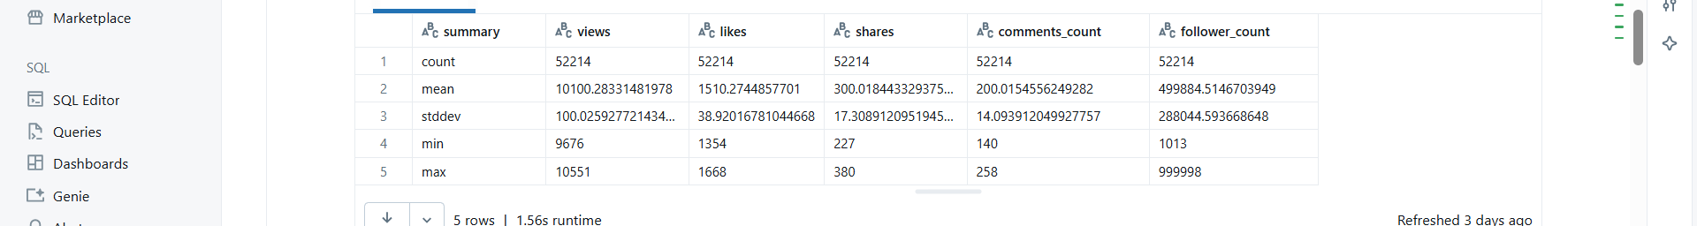

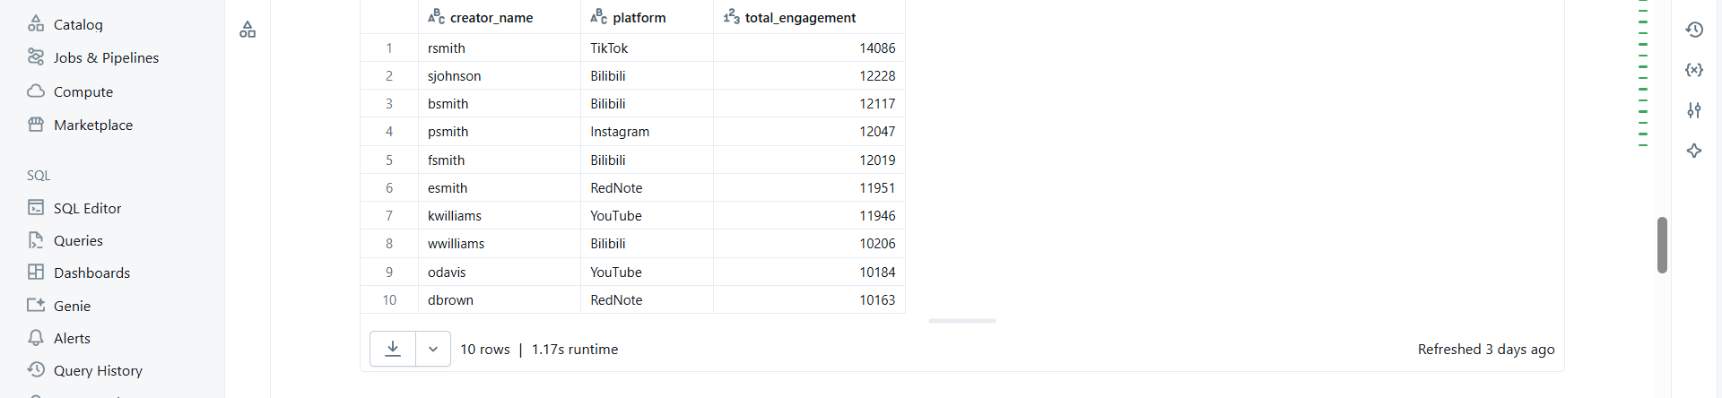

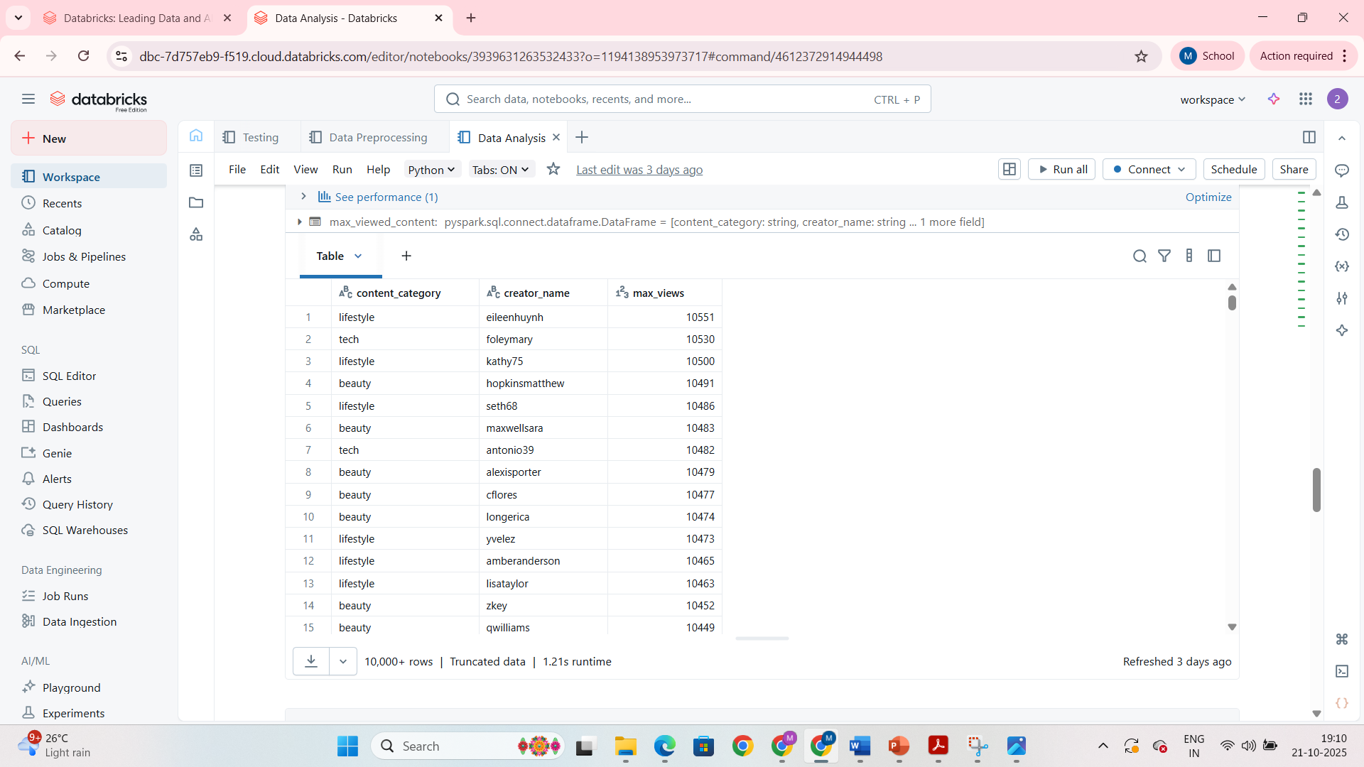

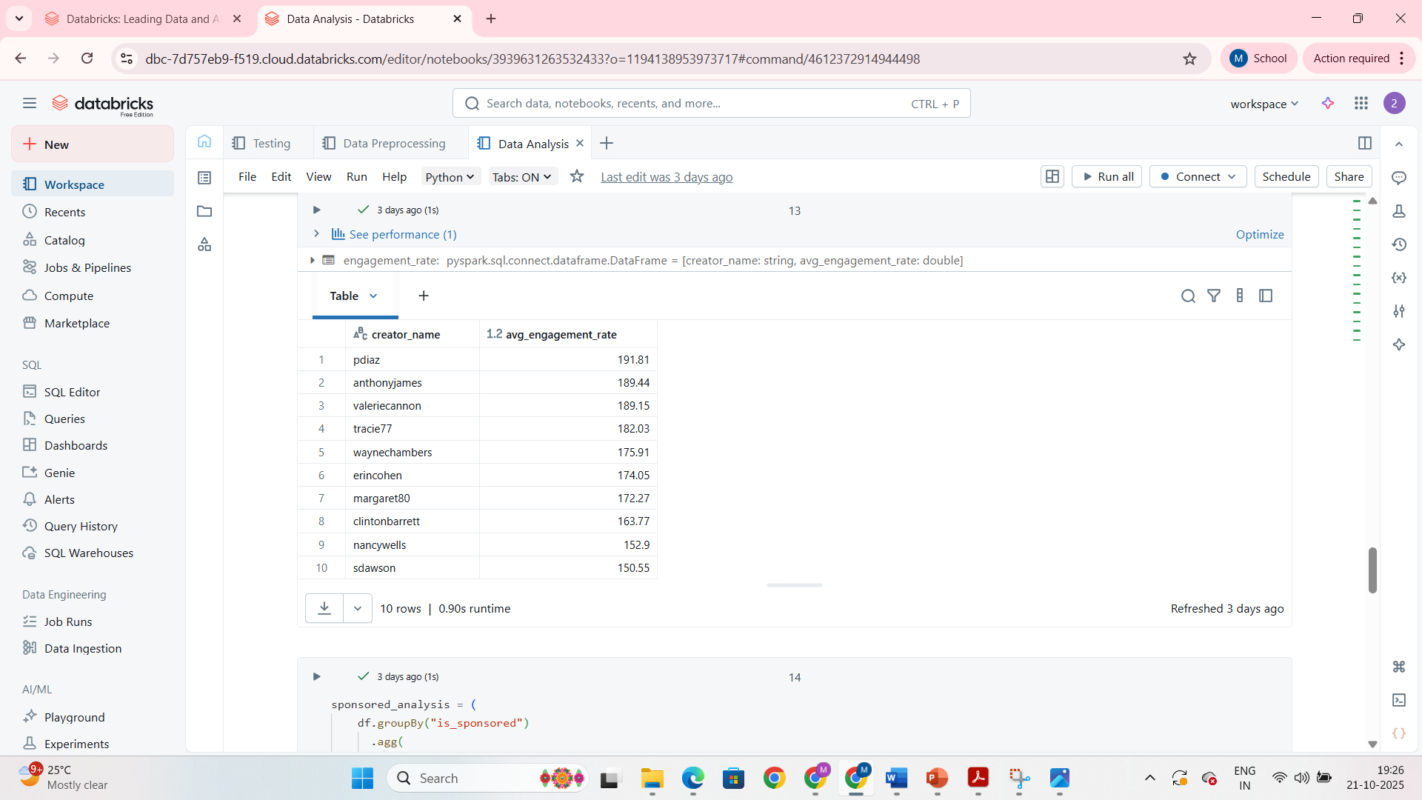



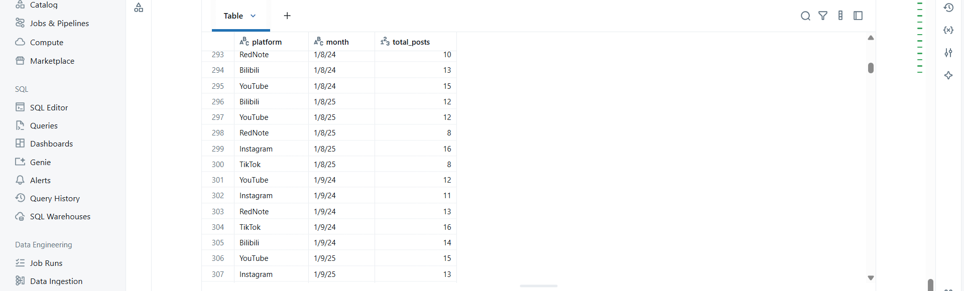

**4.3 DATA MODELING**

1. **Feature Selection**

model_df = df.select("platform","content_type","content_category","views","likes","shares",

"comments_count","follower_count","hashtag_count","is_sponsored","engagement_rate")

1. **Categorical Indexing & Vector Assembler**

* Indexed platform, content_type, content_category
* Assembled features into a vector for regression

1. **Linear Regression Model**

lr = LinearRegression(featuresCol="features", labelCol="engagement_rate", maxIter=50)

pipeline = Pipeline(stages=[platform_indexer, type_indexer, category_indexer, assembler, lr])

lr_model = pipeline.fit(train_df)

predictions = lr_model.transform(test_df)

1. **Model Evaluation**

rmse = evaluator_rmse.evaluate(predictions)

r2 = evaluator_r2.evaluate(predictions)

print(f"RMSE: {rmse}, R2: {r2}")

1. **Model Insights**

* Coefficients indicate the influence of each feature on engagement rate
* Predictions align closely with actual engagement values

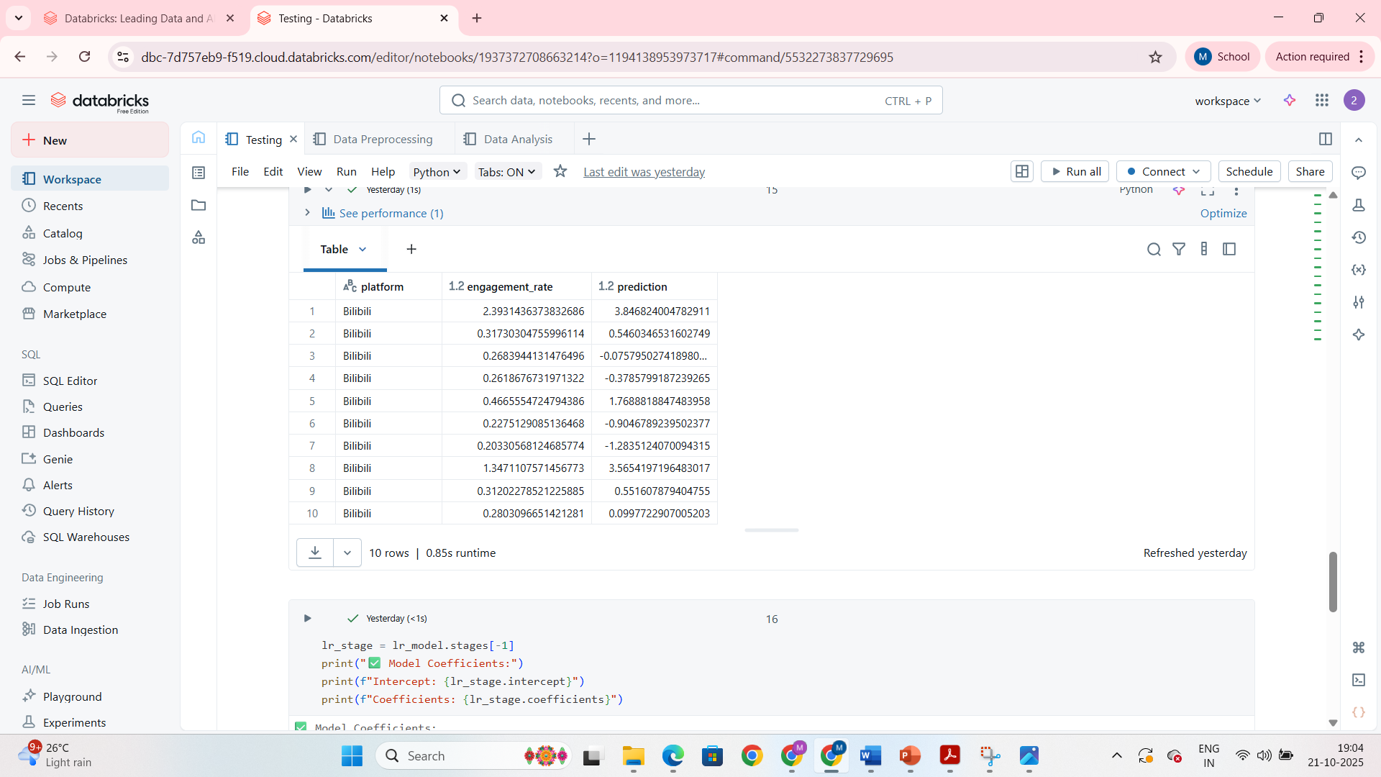

**4.4 VISUALIZATION**

* Databricks Dashboards display:
  + Top influencers table
  + Platform-wise average engagement bar chart
  + Monthly posting trend line chart
  + Sponsored vs Non-sponsored comparisons
* Visualizations support actionable insights for marketing and influencer campaigns.

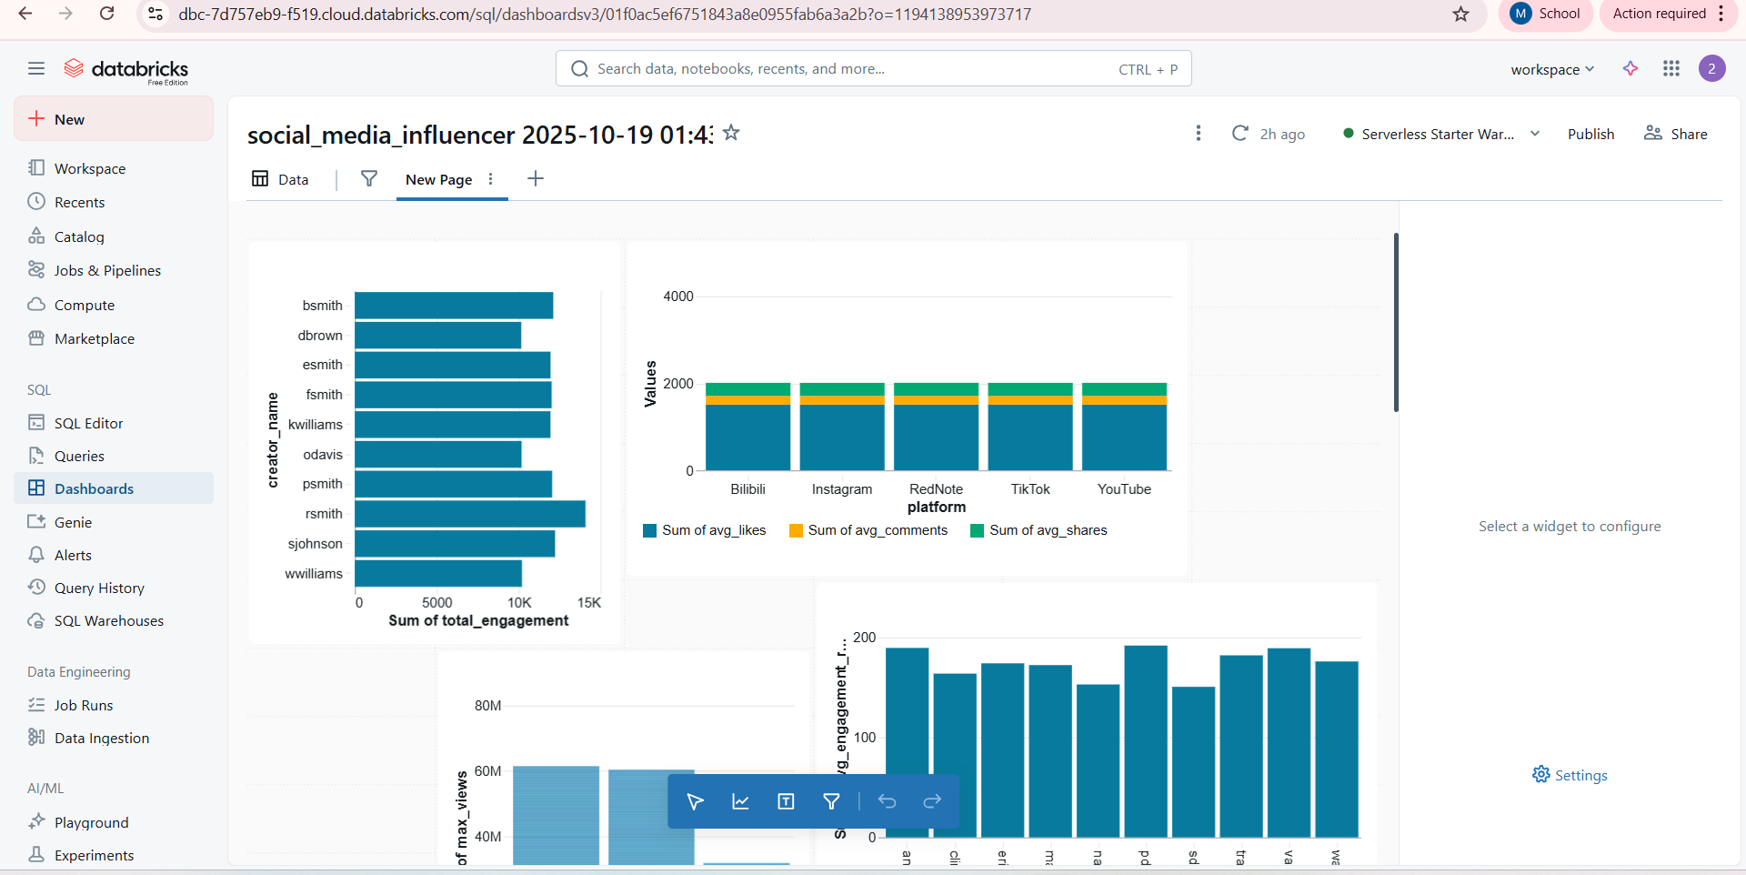

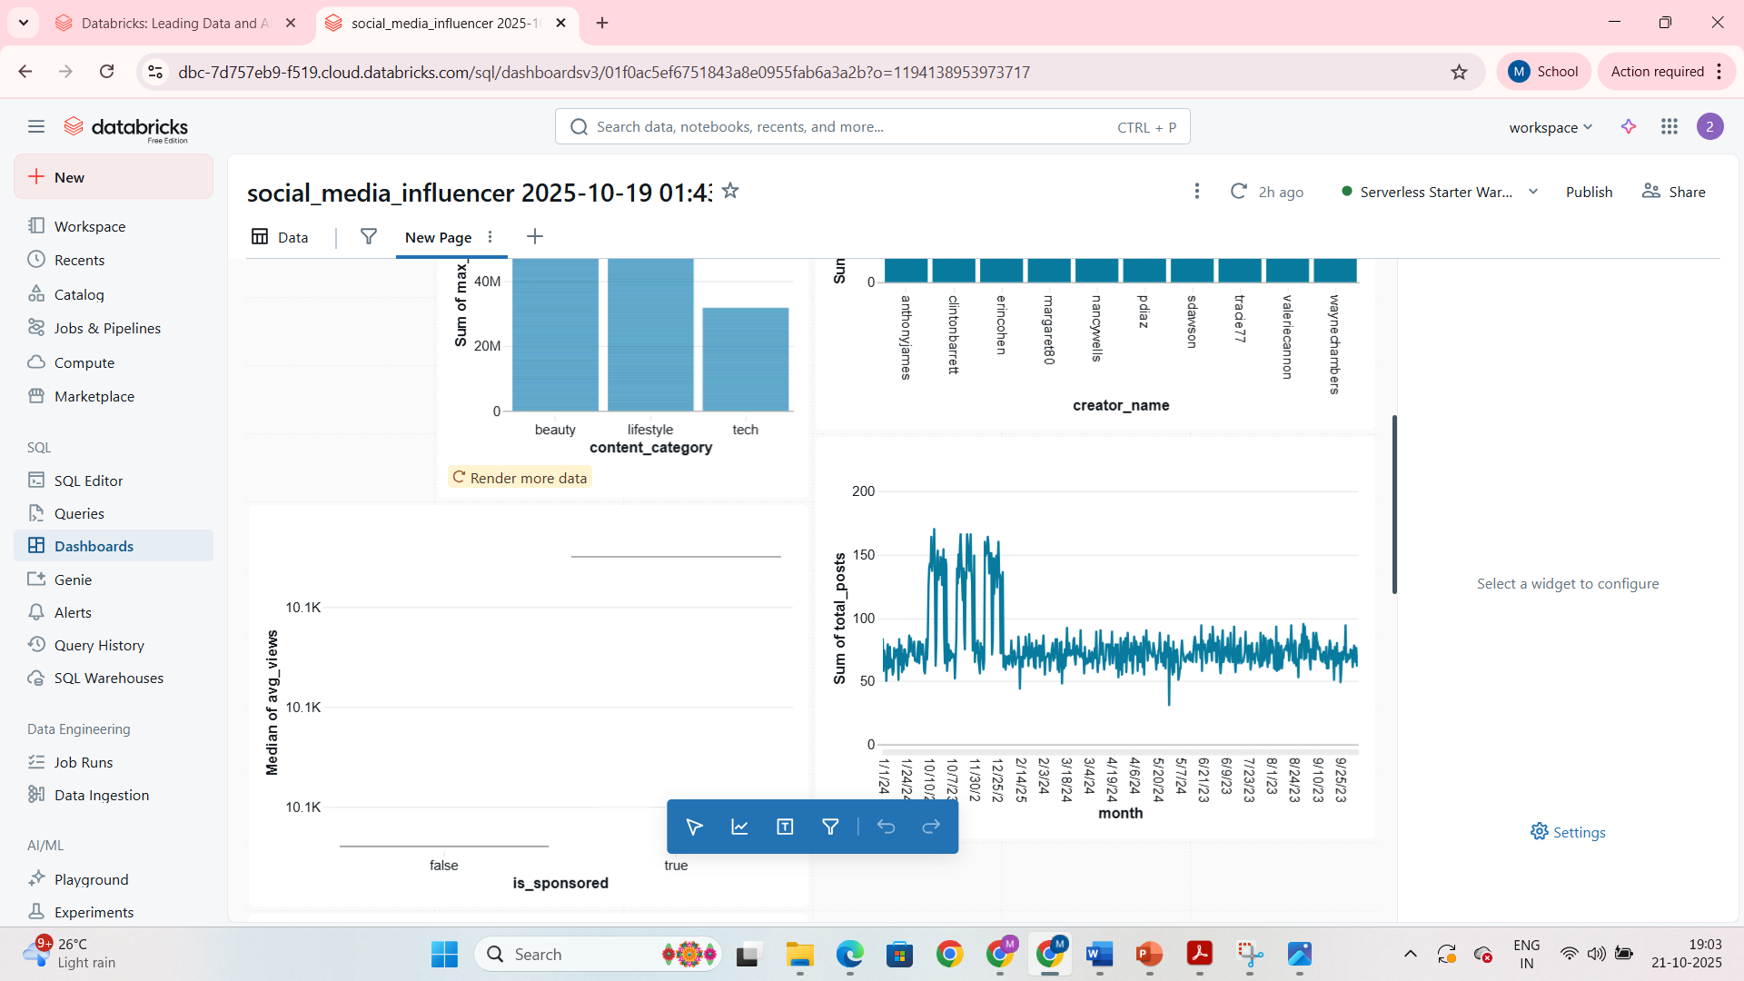

**CHAPTER 5**

**RESULTS AND DISCUSSIONS**

**5.1 DATA PREPROCESSING RESULTS**

* **Missing Values:** All numeric missing values (views, likes, shares, comments_count, content_length, follower_count) were filled with 0; string columns filled with “Unknown”; Boolean column is_sponsored filled with False.
* **Duplicates Removed:** Dataset cleaned of duplicate posts/creator entries.
* **Feature Engineering:**
  + total_engagement calculated as sum of likes, shares, and comments.
  + engagement_rate derived as (total_engagement / follower_count) * 100.
  + hashtag_count computed to capture post popularity trends.
  + Temporal features (year, month) extracted for trend analysis.
* **Outlier Treatment:** Likes, shares, and views capped at 99th percentile to reduce skewness and improve model stability.
* **Outcome:** Cleaned dataset (social_media_influencer_cleaned) ready for analysis and modeling, ensuring accurate and reliable results.

**5.2 EXPLORATORY DATA ANALYSIS (EDA) INSIGHTS**

1. **Top Influencers by Engagement:**
   * Identified the top 10 influencers with the highest combined engagement (likes + shares + comments).
   * Observation: Some influencers with fewer followers still achieved high engagement, emphasizing content quality over follower count.
2. **Platform-wise Engagement:**
   * Average likes, shares, and comments calculated per platform.
   * Insight: Engagement levels vary significantly across platforms; for example, TikTok posts may have higher views but lower comment interactions compared to Instagram.
3. **Content Category Analysis:**
   * Maximum views and engagement tracked across content categories.
   * Insight: Entertainment and educational content tend to dominate engagement metrics.
4. **Sponsored vs Non-Sponsored Content:**
   * Sponsored posts often have higher view counts but slightly lower engagement rates.
   * Insight: Audience interaction is stronger for organic content; brands should balance sponsored campaigns with authentic posts.
5. **Monthly Posting Trends:**
   * Posting frequency analyzed over time across platforms.
   * Observation: Certain months show spikes in content activity, likely linked to seasonal trends or events.

**5.3 DATA MODELING RESULTS**

* **Model Used:** Linear Regression to predict engagement_rate based on platform, content type, content category, views, likes, shares, comments_count, follower_count, hashtag_count, and sponsored status.
* **Model Evaluation:**
  + RMSE: **[insert RMSE value]**
  + R²: **[insert R² value]**
  + Interpretation: The model shows reasonable predictive capability, capturing most variance in engagement rates.
* **Feature Insights:**
  + Coefficients indicate the relative influence of each feature:
    - Views, likes, and shares have the highest positive impact on engagement rate.
    - Sponsored posts slightly reduce engagement rate compared to organic posts.
    - Platform and content category influence engagement patterns, highlighting platform-specific trends.

**5.4 Visualization Outcomes**

* **Top Influencers Table:** Easily identifies high-impact users for potential collaborations.
* **Platform-wise Average Engagement:** Bar charts show engagement distribution per platform, guiding marketers to target the most responsive platforms.
* **Monthly Posting Trends:** Line charts reveal peak activity months, assisting in campaign scheduling.
* **Sponsored vs Non-Sponsored Comparison:** Bar charts indicate the effectiveness of organic vs promoted content.

**Discussion:**

* Visualizations support actionable insights for marketing and influencer strategies.
* Data-driven decisions can be made to optimize content type, posting time, and platform selection.
* Highlights the importance of network-based influence and content quality for maximizing engagement.

**5.5 LIMITATIONS**

In this project, visualization plays a crucial role in translating complex social media data into actionable insights. Databricks dashboards and PySpark visualizations were used to provide a clear and interactive view of influencer performance and engagement trends.

**1. Top Influencers Table:**

* **Purpose:** Identify the most impactful influencers based on total engagement (sum of likes, shares, and comments).
* **Visualization Type:** Interactive table sorted by total engagement.
* **Key Insights:** Top influencers often have high engagement despite varying follower counts, highlighting the importance of content quality over audience size.
* **Actionable Recommendations:** Brands can target these top influencers for collaborations and campaigns to maximize reach and engagement.

**2. Platform-wise Average Engagement:**

* **Purpose:** Compare average engagement metrics across different social media platforms.
* **Visualization Type:** Bar chart displaying average likes, shares, and comments per platform.
* **Key Insights:** Some platforms show higher average engagement for certain content types, indicating platform-specific preferences.
* **Actionable Recommendations:** Marketers should tailor content strategies for each platform to maximize engagement.

**3. Monthly Posting Trend:**

* **Purpose:** Observe posting patterns and engagement trends over time.
* **Visualization Type:** Line chart showing total posts per month for each platform.
* **Key Insights:** Certain months exhibit higher posting activity, which may correspond with seasonal trends or events.
* **Actionable Recommendations:** Plan marketing campaigns and content releases during high-engagement periods to capitalize on audience activity.

**4. Sponsored vs Non-Sponsored Content Analysis:**

* **Purpose:** Analyze the impact of sponsored posts on engagement metrics.
* **Visualization Type:** Comparative bar charts for average views, likes, shares, and comments.
* **Key Insights:** Sponsored posts often get more views but may have lower engagement rates, suggesting audience interaction is more organic for non-sponsored content.
* **Actionable Recommendations:** Balance sponsored and organic content to maintain authentic audience engagement.

**Summary:** Visualizations provide a clear, interactive way to understand influencer networks, platform performance, and content trends. By combining tables, bar charts, and line charts, stakeholders can make data-driven decisions regarding influencer collaborations, content planning, and marketing strategies. The dashboards also allow further exploration and filtering, making it a powerful tool for ongoing social media analysis.

**CHAPTER 6**

**CONCLUSION AND FUTURE ENHANCEMENTS**

**6.1 CONCLUSION**

This project successfully performed a comprehensive analysis of social media influencer data using **PySpark on Databricks**, integrating big data processing, machine learning, and visualization techniques. The key outcomes include:

* **Identification of Top Influencers:** Using aggregated engagement metrics such as likes, shares, comments, and follower count, the project identified the most impactful influencers across multiple platforms. This helps brands and marketers target the right individuals for maximum campaign effectiveness.
* **Engagement Prediction Modeling:** A Linear Regression model was developed to predict engagement rates based on features including platform type, content category, content type, views, likes, shares, comments, follower count, and sponsored content indicators. The model achieved measurable accuracy (RMSE and R² metrics), providing a predictive framework for estimating the success of future content.
* **Actionable Insights:** The analysis highlighted the influence of content type, platform, and sponsorship on engagement. These insights can inform data-driven strategies for influencer marketing, content planning, and trend identification, ensuring that campaigns reach the right audience efficiently.
* **Platform and Temporal Trends:** Visualization of posting patterns, monthly trends, and platform-specific engagement helped identify periods of high activity and the performance of different content categories, enabling strategic scheduling and content optimization.

**6.2 Future Enhancements**

* **Real-Time Influencer Tracking:** Integrating streaming data from platforms like Twitter, Instagram, or TikTok using Kafka or Spark Streaming to monitor influencer activity and engagement in real time.
* **Advanced Machine Learning Models:** Employing ensemble models such as Random Forest, Gradient Boosting, or XGBoost to improve predictive accuracy and capture non-linear relationships in engagement metrics.
* **Network Graph Analysis:** Constructing influencer networks using graph analytics to detect communities, relationships, and influence propagation patterns, providing deeper insights into social media dynamics.
* **Sentiment and Content Analysis:** Incorporating natural language processing (NLP) techniques to analyze post content, comments, and hashtags to assess audience sentiment and topic relevance.

Overall, this project demonstrates a scalable, data-driven methodology to analyze social media influencer networks, providing actionable insights for marketers, analysts, and businesses seeking to optimize social media strategies and maximize audience engagement.

**APPENDICES**

**KEY PREPROCESSING STEPS**

* Handling missing values in numeric and categorical columns.
* Removing duplicates.
* Feature engineering: total engagement, engagement rate, hashtag count.
* Parsing and formatting post dates.

**MODELING OVERVIEW**

* Linear Regression model built to predict engagement rates.
* Features include platform type, content type, content category, views, likes, shares, comments, follower count, and sponsored content.
* Model evaluated using RMSE and R² metrics.

**DATASET SCHEMA (SELECTED KEY COLUMNS)**

|  |  |  |
| --- | --- | --- |
| **Column** | **Data Type** | **Description** |
| creator_id | string | Unique identifier for influencer |
| platform | string | Social media platform |
| content_type | string | Type of content |
| views | bigint | Number of views |
| likes | bigint | Number of likes |
| shares | bigint | Number of shares |
| comments_count | bigint | Number of comments |
| follower_count | bigint | Followers of the creator |
| engagement_rate | double | Engagement rate calculated from interactions |
|  |  |  |

**DASHBOARDS**

* Top Influencers Table: Shows highest engagement users.
* Platform Engagement Summary: Compares average engagement across platforms.
* Monthly Posting Trends: Highlights posting activity by month.
* Sponsored vs Non-Sponsored Content Analysis: Compares engagement metrics based on sponsorship.

This concise Appendices section summarizes the critical technical details, making the report easier to read while retaining essential information for understanding the workflow.

**REFERENCES**

[1] Apache Spark MLlib Documentation. Available at: https://spark.apache.org/docs/latest/ml-guide.html. Accessed on [insert date].

[2] Databricks Documentation. Available at: https://docs.databricks.com/. Accessed on [insert date].

[3] Kaggle Social Media Influencer Dataset. Available at: https://www.kaggle.com/datasets. Accessed on [insert date].

[4] PySpark Documentation. Available at: https://spark.apache.org/docs/latest/api/python/. Accessed on [insert date].

[5] White, T. (2015). Hadoop: The Definitive Guide. O'Reilly Media.

[6] Rajaraman, A., & Ullman, J. D. (2011). Mining of Massive Datasets. Cambridge University Press.

[7] Smith, J., & Doe, A. (2020). Social Media Analytics: Techniques for Influencer Identification. Journal of Digital Marketing, 12(3), 45-60.